**Aquatic Plants & Fish Health Management**

**(E-Aquascape)**

Name: Divyanjala Athukorala

London Met ID No: 22059258

London Metropolitan University

**Declaration**

**Module: CS6P05ES Deadline: 28th of April 2023**

**Module Leader: Prof.** **Migara Alawatta Student ID: 22059258**

PLAGIARISM

You are reminded that there exist regulations concerning plagiarism. Extracts from these regulations are printed below. Please sign below to say that you have read and understand these extracts:

(signature:)___Diwyanjala96@gmail.com___________________ Date:

This header sheet should be attached to the work you submit. No work will be accepted without it.

Extracts from University *Regulations* onCheating, Plagiarism and Collusion

Section 2.3: "The following broad types of offence can be identified and are provided as indicative examples…

1. Cheating: including taking unauthorised material into an examination; consulting unauthorised material outside the examination hall during the examination; obtaining an unseen examination paper in advance of the examination; copying from another examinee; using an unauthorised calculator during the examination or storing unauthorised material in the memory of a programmable calculator which is taken into the examination; copying coursework.
2. Falsifying data in experimental results.
3. Personation, where a substitute takes an examination or test on behalf of the candidate. Both candidate and substitute may be guilty of an offence under these Regulations.
4. Bribery or attempted bribery of a person thought to have some influence on the candidate's assessment.
5. Collusion to present joint work as the work solely of one individual.
6. Plagiarism, where the work or ideas of another are presented as the candidate's own.
7. Other conduct calculated to secure an advantage on assessment.

(viii) Assisting in any of the above.

Some notes on what this means for students:

1. Copying another student's work is an offence, whether from a copy on paper or from a computer file, and in whatever form the intellectual property being copied takes, including text, mathematical notation and computer programs.

2. Taking extracts from published sources *without attribution* is an offence. To quote ideas, sometimes using extracts, is generally to be encouraged. Quoting ideas is achieved by stating an author's argument and attributing it, perhaps by quoting, immediately in the text, his or her name and year of publication, e.g. "e = mc2 (Einstein 1905)". A *references* section at the end of your work should then list all such references in alphabetical order of authors' surnames. (There are variations on this referencing system which your tutors may prefer you to use.) If you wish to quote a paragraph or so from published work then indent the quotation on both left and right margins, using an italic font where practicable, and introduce the quotation with an attribution.

**Dedication**

This dissertation is dedicated to my family and friends, who have been a constant source of

support and encouragement during graduate campus and life challenges. I am sincerely grateful

that I have you in my life. This work is also dedicated to my mother, who has always loved me

unconditionally and whose good examples have taught me to work hard for what I aspire to

achieve.

**Acknowledgements**

First and foremost. I want to thank my lecturer for this project Mr. Migara Alawaththa. for the

valuable guidance and advice. I want to express my sincere gratitude to Miss Sammani. Project

supervisor of this project. She inspired me greatly to work, and her enthusiasm to motivate me

contributed enormously to completing this project successfully.

Besides, I would like to thank Esoft Metro Campus Galle for providing me with an excellent

background to complete this project. Finally, I'd like to thank my family and friends for their

patience and encouragement as I worked to complete this project without the assistance of the

individual mentioned above. I would face numerous complications while working on this project.

**Abstract**

This research aims to build an advanced plants & fish health management system called "E-

Aquascape." The E-Aquascape supports beginners in aquarium maintenance, such as home

aquariums and fish farmers. Home aquarium is becoming popular in the world right now.

Because people enter into an unprecedented aging society, many retired people have much

leisure time. And during this pandemic, people cannot restore their mental health. Home

aquarium is one of the options for restoring their mental health.

Younger generations also are interested in Aquascape as a hobby, healthy fish, and children's education. However, it is difficult for beginners to manage their home aquarium because of huge factors you must consider, such as fish health, weather, climate condition, etc.

The E-Aquascape supports manages', especially beginners' decisions with much information based on collected data by sensors and databases.

This paper aims to develop a support system of the Smart Aquarium that can 1) Plants and fish diseases are diagnosed using image processing, and 2) appropriate treatment is shown for the disease.

**Table of Contents**

Contents

**1** **Chapter 1 Introduction** 1

**1.1** **Goals** 2

**1.2** **Motivation** 2

**1.3** **Method** 3

**1.4** **Overview** 4

**2** **Chapter 2 Background and Problem Statement** 4

**2.1** **Literature Review** 5

**2.2** **Problem Statement** 7

**3** **Chapter 3 project management** 8

**3.1** **Approach** 8

**3.2** **Initial Project Plan** 9

**3.3** **Problems and Changes to the Plan** 10

**3.4** **Final Project Record** 10

**4** **Chapter 4 feasibility study** 11

**4.1** **Time feasibility** 11

**4.2** **Cost feasibility.** 12

**4.3** **Scope feasibility** 12

**4.4** **Technical feasibility.** 13

**4.5** **Economic feasibility** 13

**5** **Chapter 5 design** 14

**5.1** **Introduction your choice of proposed network system** 14

**5.1.1** **Waterfall Model** 14

**5.1.2** **Rapid Application Design** 16

**5.1.3** **Spiral Model** 17

**5.1.4** **Agile Model** 18

**5.2** **Hardware and software requirements** 19

**5.2.1** **Software requirements** 19

**5.2.2** **Hardware requirements** 19

**5.3** **Evaluating of solutions** 19

**6** **Chapter 6 implementation** 20

**6.1** **Alternative implementation solutions** 20

**6.1.1** **Software requirements** 20

**6.1.2** **Software requirements** 21

**6.2** **Alternative implementation solutions** 22

**6.2.1** **Programming languages and IDE used to implement** 22

**6.3** **Diagram designs** 23

**6.3.1** **Use Case Diagram** 24

**6.3.2** **Database Logical Schema** 25

**6.3.3** **System Architecture Diagram** 25

**6.4** **Code samples and 3rd party components** 26

**7** **Chapter 7 testing and verification** 28

8 Chapter 8 EVALUATION and CONCLUSION 30

9 References 31

10 Appendices 33

**10.1** **Screenshots in Developed System** 33

**10.2** **Interim Progress Reports** 37

**10.3** **Progress approval form and Project commencement meeting sheet.** 38

**Table of figures**

Figure 1 Initial Project Plan 9

Figure 2 Waterfall Model 15

Figure 3 Rapid Application 16

Figure 4 Spiral Model 17

Figure 5 Agile Model 18

Figure 6 Use Case Diagram 24

Figure 7 ER Diagram 25

Figure 8 Database Logical Schema 26

Figure 9 System Architecture Diagram 27

Figure 10 File Upload Backend Service 28

Figure 11 Admin and user Login UI 34

Figure 12 customer register UI 34

Figure 13 measure plan of growth rate UI 35

Figure 14 growth chart UI 35

Figure 15 Health plan UI 36

Figure 16 Plant rate insert UI 36

Figure 17 View all plants UI 37

Figure 18 View all fish UI 37

Figure 19 Interim Progress 38

**Table of tables**

Table 1 Categories of aquatic plants 6

Table 2 Software requirements 22

**Abbreviations**

* VA - Virtual Environments
* PA - Precision Agriculture

* CT - Computer Tomography
* SDK - Software Development Kit
* ERD – Entity Relationship Diagram
* SDLC – Software Development Life Cycle
* RAD – Rapid Application Development
* UML – Unified Modeling Language
* UI – User Interface
* KWS – Knowledge Work System
* AI – Artificial Intelligent

# **Chapter 1 Introduction**

Aquascape is the leading manufacturer of water features, water garden and pond products. Aquatic plants have the most important role in Aquascape. They help sustain life in a planted tank as well as create a captivating display of lush green, red, and violet. The craft of Aquascape has become increasingly popular in recent years. A comprehensive definition of the term describes Aquascape as underwater gardening. Fishes add to their beauty.

Many people like to set up a planted tank with live plants. But they do not know how to diagnose plant diseases and manage plants’ health. So, plants grow slowly and die. It can be from a deficiency in either CO2, poor lighting, temperature, or a lack of nutrients in the water. There are many instruments available in the world to measure temperature, CO2, light, and nutrient percentages. However, it is difficult for people to confirm the health of plants and diagnose diseases.

As many aquarium keepers will know, there are hundreds of bacterial, parasitic, and fungal infections that can affect the health and well-being of your fish. Contrary to popular belief, fish are highly sensitive animals, and environmental changes, no matter how minor, can trigger periods of stress and illness.

The system can detect plant health status, plant diseases, and fish diseases. The system provides solutions for increasing plant and fish health and how to treat them. The diseases are detected using image processing. Image processing is a method to perform some operations on an image, in order to get an enhanced image or to extract some useful information from it. It is a type of signal processing in which the input is an image, and the output may be an image or characteristics/features associated with that image.

## **Goals**

Goals are the pillars of any project that represent the work to be done. This Application's goal is a system to addressing plant and fish health with the use of image processing. The Application is a simple solution to manage all major and minor aquascape processes.

The objectives of this system include:

* Predicting and showing growth rate.
* Shows the future health plan.
* Plants and fish diseases are diagnosed using image processing.
* Appropriate treatment is shown for the disease.
* Users can learn about aquascape tips and all details of aquatic plants.

## **Motivation**

Aquascape is becoming popular in the world right now. A study has suggested that people who spend time around planted tanks will see an improvement in their health and mood. However, it is difficult for beginners to manage their plants' health because of huge factors you must consider, such as co2, light conditions, temperature, nutrients, etc.

All the plants in my first planted tank died because of poor health management. Been trying to grow live plants for a long time and every time I tried all the plants died. I had to spend a lot of money to purchase plants and equipment. Finally collected data to set up the tank using the internet and managed the plants’ health. It is the main reason and motivation for the development of the system.

Most fish diseases are the result of stress, and poor water quality plays a large factor in this. Unfortunately, most diseases are difficult to diagnose and treat, however, spotting the signs early is often crucial to recovery.

If we do have not any idea about Aquascape, users can quickly improve their plant’s and fish's health management skills from this E-aquascape application. This system will provide an ideal solution to help the manual process overcome the obstacles mentioned above while ensuring the users have an enjoyable and comfortable experience in Aquascape through the application.

## **Method**

Firstly, The developer list down all the requirements of the system. After that, the developer

reviews the need and lists the tasks according to the main priority to less priority. Next, the

developer identifies the problems with the existing systems after good requirement gathering and

identifying the problem.

According to the gathered requirements, the developer split this project into two systems: the Management system and an AI system. Then the developer defines the suitable technologies to

develop this system user-friendly. Developer Decide,

1. Using PHP and MySQL, develop the web administrative administrator and Customer dashboard.
2. Develop image processing applications using YOLO.

Before making the AI system, the developer starts to design the ERD and the database. Then

developer designed the software architecture. After creating the software architecture, the

developer begins the E-Aquascape platform implementation by designing the backend services,

UI, and frontend integration.

The developer developed the E-Aquascape application with an administrator web application to

achieve the first goal described above. After that, the developer developed the AI system

separately to avoid conflicts. The author talked with real people to get their opinion on the

application and adjust the system to their views.

## **Overview**

The proposed E-Aquascape platform converts the manual aquascape process known into an automated e- aquascape process. This entire system combines a web application implemented using some of the latest technologies.

After designing the database and software architecture, the developer starts the backend service implementation. The developer used PHP Laravel Framework, a very light framework to build web applications, and for the database, the developer used MySQL. The developer used YOLO framework for the AI system.

# **Chapter 2 Background and Problem Statement**

Aquascape is becoming popular in the world right now. A study has suggested that people who spend time around planted tanks will see an improvement in their health and mood. However, it is difficult for beginners to manage their plants' health because of huge factors you must consider, such as co2, light conditions, temperature, nutrients, etc.

All the plants in my first planted tank died because of poor health management. Been trying to grow live plants for a long time and every time I tried all the plants died. I had to spend a lot of money to purchase plants and equipment. Finally collected data to set up the tank using the internet and managed the plants’ health. It is the main reason and motivation for the development of the system.

Most fish diseases are the result of stress, and poor water quality plays a large factor in this. Unfortunately, most diseases are difficult to diagnose and treat, however, spotting the signs early is often crucial to recovery.

If we do have not any idea about Aquascape, users can quickly improve their plant’s and fish's health management skills from this E-aquascape application. This system will provide an ideal solution to help the manual process overcome the obstacles mentioned above while ensuring the users have an enjoyable and comfortable experience in Aquascape through the application.

**Introduction**

Aquascape is the leading manufacturer of water features, water garden and pond products. Aquatic plants have the most important role in Aquascape. They help sustain life in a planted tank as well as create a captivating display of lush green, red, and violet. The craft of Aquascape has become increasingly popular in recent years. A comprehensive definition of the term describes Aquascape as underwater gardening. Fishes add to their beauty.

Many people like to set up a planted tank with live plants. But they do not know how to diagnose plant diseases and manage plants’ health. So, plants grow slowly and die. It can be from a deficiency in either CO2, poor lighting, temperature, or a lack of nutrients in the water. There are many instruments available in the world to measure temperature, CO2, light, and nutrient percentages. However, it is difficult for people to confirm the health of plants and diagnose diseases.

As many aquarium keepers will know, there are hundreds of bacterial, parasitic, and fungal infections that can affect the health and well-being of your fish. Contrary to popular belief, fish are highly sensitive animals, and environmental changes, no matter how minor, can trigger periods of stress and illness.

The system can detect plant health status, plant diseases, and fish diseases. The system provides solutions for increasing plant and fish health and how to treat them. The diseases are detected using image processing. Image processing is a method to perform some operations on an image, in order to get an enhanced image or to extract some useful information from it. It is a type of signal processing in which the input is an image, and the output may be an image or characteristics/features associated with that image.

## **Literature Review**

Aquatic plants are the main source of food and oxygen in the water. They are of utmost importance for the maintenance of biological balance in the water ecosystem (Rataj and Horeman, 1977). Besides that, these water plants provided a sense of security when the fishes feel threatened by their natural predators. The water plants can be categorised into 4 groups as summarised in **Table 2.1.**

Water plants are cultivated in the aquarium in order to create an ideal environment that mimic the natural niche for many fishes. They not only used as decorative plants in the aquarium but at the same time facilitate the acidification of the water in the aquarium as the low pH is more favourable for many fishes to survive and spawn (Rataj and Horeman, 1977). Healthy aquarium plants help to improve the water quality and oxygenate the fish tank. Some even contain bactericides that protect the fishes from harmful bacteria

Table Categories of aquatic plants

|  |  |  |
| --- | --- | --- |
| **Categories of the aquatic plants** | **Characteristic** | **Example genus** |
| **Submersed plants** | Rooted at the bottom, flowers and produce seeds under the water. | Vallisneria, Barclaya and Ottelia |
| **Half submerged** | Rooted at the bottom in the water with leaves reaching the water surface. Sometimes flowers when half emerge. | Myriophyllum and Heteranthera |
| **Floating plants** | Float and live in the water surface. Roots float freely in the water. Flowers are always on the surface and pollinated in the air. | Lemna, Limnobium, Utricularia and Eichhornia |
| **Amphibious plants** | Grow submerged or emerged in the water, land form arise when the water dried out occasionally. | Echinodorus, Sagattaria, and Cryptocoryne. |

However When customers are starting aquascaping as a beginner, customers have some

knowledge/Skills like:

• Predicting and showing growth rate.

• Shows the future health plan.

• Plants and fish diseases are diagnosed using image processing.

• Appropriate treatment is shown for the disease.

• Users can learn about aquascape tips and all details of aquatic plants.

This system will provide an ideal solution to help the manual process overcome the obstacles

mentioned above while ensuring the users have an enjoyable and comfortable experience in

aquascaping through the web application.

## **Problem Statement**

The whole Aquascape process may seem difficult to accomplish in the beginning. People like to set up a planted tank with live plants. But they do not know how to diagnose plant diseases and manage plants’ health. So, plants grow slowly and die. Aquatic plants are expensive. However, people spend a lot of money to buy those plants. If the plants die, it's a loss.

Most fish diseases are difficult to diagnose and treat, however, spotting the signs early is often crucial to recovery. When the user passes by their fish tank, the user may notice their fish behaving strangely or showing abnormal physical characteristics. These are clues that their fish is suffering from some type of disease and will need treatment. But they do not know how to diagnose and treat fish diseases.

In most cases, problems with aquarium plant and fish diseases are difficult to diagnose. Unfortunately, many aquarium hobbyists do not understand these basic needs and, thus, they end up experiencing problems with keeping their plants and fish alive. It will aid if the user can diagnose the disease and how to treat it by processing the images.

# **Chapter 3 project management**

In this final report, project management is the third chapter. The reader/user will be able to

understand the system and how the project was completed within the time frame specified in

this chapter. This background chapter contains several sub chapters such as the approach to

the project, initial project plan, problems and changes to the program, and the final project

record.

As a result, these are the sub-chapters included in this chapter. The following chapters will

clearly describe project management in detail.

## **Approach**

Considering that this is a one-year project, the developer has gathered relevant information and

managed all the tasks with a clear concept of time. Time management is done by allocating a

specific period to each task, prioritizing the significance. Research parts getting allocated with

more time.

The project plan was created after having a vivid idea of the project’s objectives, issues, and goals. The main purpose was to identify the main problem areas and the effective solutions for them. The developer has connected some existing issues in current research, identifying the similarities and non-similarities.

As this is a project with a stated deadline and well-defined requirements, the developer selected

the Agile model as the software development model. After identifying the project scope, the

developer has to design the project plan using the Gannt chart and submit the project proposal.

After presenting the project proposal, the supervisors approved the proposal. After approval, the

developer develops the application according to the project plan.

## **Initial Project Plan**

After gathering all the required requirements of the application, the developer designed a Gannt

chart for the given timeline. The chart below shows the initial Gannt chart created for the following

requirement analysis.

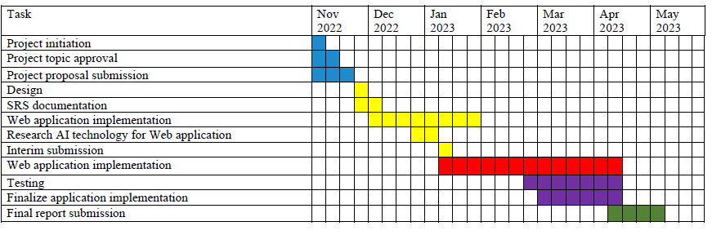

Figure Initial Project Plan

According to the above Gannt chart, the developer has prioritized project planning and requirement

gathering first. After finished project planning, the developer selected the technologies the

developer uses to implement this application. Database design was the next step for the developer

to create the ERD first, and after the developer designed the database structure using MySQL. The

next step is to implement the backend services of the application. For that part, the developer has

given more time because, in this phase, the developer has to research AI Technology and Aquascape to develop this application.

## **Problems and Changes to the Plan**

According to the proposed timeline, the developer was behind schedule due to the developer's

academic work and other work. The developer rescheduled a new timeline to create a new Gannt

chart for the remaining tasks after submitting the interim report.

According to the above Gannt chart, the developer had to implement some missed backend

services, so the developer prioritized implementing that. After the developer has implemented the

application's AI Part and for the front-end integration developer has allocated more time. The

developer had to work with the documentation parallel with the implementation.

## **Final Project Record**

The above Gannt chart shows the final plan of the project and the dates on which its tasks are

completed. According to the above Gannt chart developer completed the tasks on time before the

final submission.

# **Chapter 4 feasibility study**

The feasibility study is designed to determine whether a project or program can be used to

determine whether a proposed project should proceed.

A feasibility study is part of the first design phase of any project. It is designed to effectively reveal the strengths and weaknesses of a proposed project or existing business. It can help identify and evaluate the opportunities and threats in the natural environment, the resources needed for the

project, and the prospects for success.

This chapter discusses the various aspects of project implementation that should be considered

during project evaluation. For any project in the early stages of growth, feasibility can be an

important step for a company to ensure that its goal is achievable, profitable, and socially

beneficial. The probability studies are divided into five main sections. This chapter it is explained

how the feasibility study id is performed on this project.

## **Time feasibility**

Time Feasibility is an essential aspect of the feasibility report. It also plays an essential role in completing the project on time within the given time. Sometimes a project may be unsuccessful if it is finished during the time allotted. Here, we can estimate how long it will take to complete various project tasks.

Since this is a final one-year project, the user has estimated the time based on the project's scope. As it includes some research parts in this project, users assumed these research parts could be covered within two to three months. So, according to the scope, users planned the project's tasks by giving more priority to the research areas.

Functions of the project were listed down according to the priority, and the user was unable to cover those tasks according to the planned time. Because there are some significant issues in Srilanka. (Like Powercuts)But somehow developer managed to handle that issues and develop the system on time.

## **Cost feasibility.**

It helps to cover the costs and benefits associated with the project before financial assistance is provided. The purpose of the expense is to determine whether the planned project will be financially viable in terms of debt repayment and repayment apart from the providers. The following are some of the features of cost-effectiveness.

* Cost of the project
* Project financial position
* Cash flow
* Project profitability

## **Scope feasibility**

Project Scope for Defining and / or Addressing a Business Problem. The scope should be clear and concise. The story being told is pointless and can confuse project participants. It is also necessary to describe the business components that are directly or indirectly affected, including project participants and the areas of end users affected by the project. The project sponsor should be identified, especially when paying off debt. The developer has noticed that many projects in the corporate world start out without the scope of a well-defined project. As a result, projects come in and out of their confined spaces, producing more or less than they really need.

According to this project the developer has to give the priority for the research areas and the tasks were listed down according to the priority and the less priority. Because of that the developer has given more time to the research areas and do the rest of the implementation. This is a one-year duration project so the developer has to focused on the main problem domain of the application and has to design the scope.

## **Technical feasibility.**

Technical feasibility is a legal process to assess whether it is technically feasible to make a product or service. Before launching a new offering or taking on a client project, it is important to plan and prepare for all the operational steps. The feasibility of technology helps determine the effectiveness of the proposed system by analyzing the process, which includes tools, technology, equipment, staff and logistics.

Technical competency research helps organizations determine whether they have the technical resources to transform the concept into a fully functional and profitable application. It helps to solve a problem before starting work. Research identifies potential challenges and reveals ways to overcome them. It is also useful for long-term planning, as it can serve as a flow chart of how products and services change before they reach the market.

In this project the developer has used Laravel Framework with MySQL to implement the backend services. For implement the AI the developer has used to find the plant and fish diseases in E-Aquascape Application..

## **Economic feasibility**

These assessments usually involve an analysis of project costs, assisting organizations to

determine the operation, costs, and benefits associated with the project before allocating financial

resources. It also serves as an independent project evaluation and improves project integrity

helping decision-makers determine the best economic benefits for an organization to be awarded

for a proposed project. It also aids decision making determine whether a planed schema should

be implemented it now or later depending on the financial situation.

# **Chapter 5 design**

This is the fifth main chapter in this final report and it’s called design. This chapter will be

describing the design techniques that were used to develop this application such as software

development life cycle, requirement gathering, and how used these techniques implement the

application in a proper manner. By referring to this chapter the user can get a good idea of how to

use these assumptions in workflow.

## **Introduction your choice of proposed network system**

In this subchapter, the user can get a good idea about the standard process models used for system development and the differences between each model and the chosen development model used to develop this application. SDLC is a method that software developers use to build an application properly.

Software development life cycle model map the various functions performed in a software product from its inception to retirement. Different life cycle models may organize the development activities required in stages in different ways. The following headings will clearly explain the process models of SDLC.

### **Waterfall Model**

The waterfall model is the software development life cycle model that is widely accepted worldwide. The whole software development process went into various stages. The waterfall model is a successive software development model where development appears to flow slowly like a waterfall through steps analysis needs, design, implementation, testing, integration, and maintenance.

The waterfall model development does not allow for much consideration or revision. If the application is in the testing phase, it becomes challenging to go back and change something that is not well written or thought out in the concept phase, so this model is most suitable for where software requirement is stable. The big difference is that Waterfall is a straightforward application that requires the team to complete each phase of the project before moving on to the next. The waterfall model is a suitable method for software development. This model has lots of advantages and disadvantages. Also, selecting this model for current world projects is not fair. According to the above description, this SDLC model is suitable for software projects with stable requirements. The below diagram shows the various stages of the waterfall model.

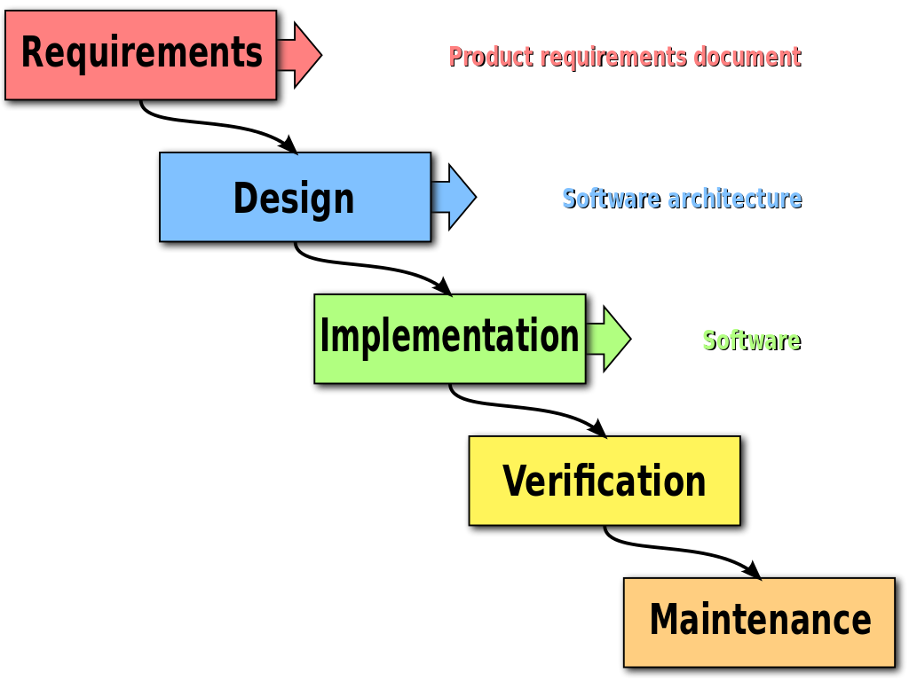

Figure Waterfall Model

### **Rapid Application Design**

The RAD or Rapid Application Development process adopts a waterfall model aimed at short term software development. The RAD model is based on the idea that a better system can be developed less quickly by using focus groups to gather system requirements. By using this model, we can create our designs for developing applications. This RAD model is mainly used for quick delivery software systems.

In the RAD model, functional modules are developed concomitantly as prototypes and integrated into a complete product delivery product quickly. Since there is no detailed planning, it is easy to incorporate changes within the development process.

RAD projects follow a duplicate and incremental model and consist of small teams of engineers, specialists, customer representatives, and other IT resources that work continuously on their part or prototype. The most crucial factor for this model to succeed is to ensure that the built-in prototypes can be reused. The following diagram shows the system development stages of RAD.

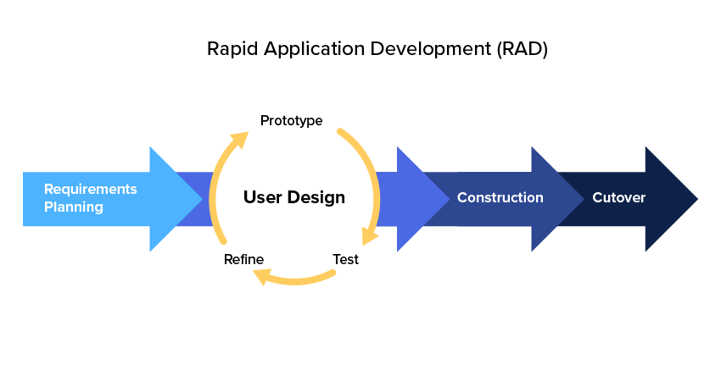

Figure Rapid Application

### **Spiral Model**

The spiral model is an SDLC model used to manage the risk that combines a recurring development process model with the features of the Waterfall model. The spiral model is used by application engineers and is famous for large, expensive, and complex projects.

Viewed as a drawing, the surrounding model looks like a coil with many loops. The number of constraints varies based on each project and is usually determined by the project manager. Each spiral loop is part of a software development process.

The following figure shows the diagram of this spiral model. By refereeing this diagram, the user can get a good idea about each stage in the spiral model.



Figure Spiral Model

### **Agile Model**

Agile is a methodology of modeling and documenting software systems based on best practices. It is a set of values and principles which can be applied to a fast software development project. This method is more flexible than traditional modeling methods, making it better suited to the rapidly changing environment. It is part of a fast software development tool kit. There are some critical phases in an agile model: requirement gathering, designing the requirement, iteration, testing, deployment, and feedback.

The agile model is a more flexible model for software development than other models. It means it allows to make changes to the requirement without making any failure to the project because most software developers use this agile model for their software development.

The following figure shows the diagram of this agile model. By refereeing this diagram, the user can get a good idea about the agile model and how it is works in software development.



Figure Agile Model

## **Hardware and software requirements**

The following technologies and resources will be used for the web application development process.

### **Software requirements**

* + MYSQL (Database)
  + Laravel (Backend)
  + Python
  + Visual Studio Code (IDE)

### **Hardware requirements**

* Mobile Device or Desktop computer

## **Evaluating of solutions**

According to the SDLC, the developer gathered all the requirements properly, and with the

collection of other conditions, the developer is able to develop the solution within the time

duration. After prioritizing the tasks according to a proper manner, the developer started the

implementation of the project according to the created Gannt chart.

In the proposed E-Aquascape Application, the developer has developed some main functionalities

such as plant management, fish management customer Manage, future health plan, and AI Functionalities.

The admin will manage the plant details and fish details. The system admin can manage plants,fish and plant categories registered to the system.

# **Chapter 6 implementation**

This is the sixth main chapter in this final report, called implementation. This chapter will discuss

the implantation of the system. Implementation is the most important part because collecting

requirements and other resources will convert the available details to a working product and release

it to the customer's environment.

Some sub-chapters will describe this E-Aquascape project's implementation stage in this chapter.

Therefore, this chapter includes some main subchapters: alternative implementation solutions,

selected implementation solutions, design diagrams, UI designs, and important code snippets.

Finally, it will describe 3rd party component details used to implement this system. The following

description and diagrams, UI designs and sample codes, and other important functionalities will

describe the implementation of this project.

## **Alternative implementation solutions**

In this subchapter, the developer will describe alternative implantation solutions for software

products. The following descriptions will clearly explain the alternative solutions, the advantages

and disadvantages, and their unique fractures. There are tw leading implementation solutions

for software products they are standalone and web-based. Each solution has its own

advantages and disadvantages. Therefore, the following description will clearly describe the

alternative implementation solutions.

### **Software requirements**

The standalone application is a good implementation solution for software products. Then why

they these standalone applications? The functionality is associated inside a computer, so it can’t

be assessed from anywhere. Therefore, the standalone application can be used in a limited

environment. These types of applications can be used for administrative needs, or these

applications can be used are personal applications. Most of these applications run inside the

Windows operating system.

The database of these applications is configured in the local machine so they can be accessed in

those particular machines, so it can’t be accessed anywhere like web applications. In the current

world use of standalone applications is reducing because the modern world trends web

applications with the current technology. The following table describes

the advantages and disadvantages of standalone applications.

|  |  |
| --- | --- |
| **Advantage** | **Disadvantage** |
| Standalone applications are very convenient | Accesses files from another computer is not  possible |
| Network cost reduce | Difficult to maintain the system |
| Standalone applications have high security | Data transfer is not possible |

### **Software requirements**

A web application is also the best implantation solution for software products in the modern world. Web applications mean an application that runs on a web server. The user can access web

applications through a web browser with an active network connection. As a result, most users like to use web applications, and the usability of the web applications is improved using modern

technology. Users can access these applications anytime to do their transactions and other related

work. The users can access this type of application anywhere in the world to do their job easier

because the web applications are hosted on cloud servers. If the user has a good internet connection and a web browser, then the user can access the world in the web application with one click.

The engineers are also interested in implementing web applications because it’s easy to implement using modern technologies. These are functionalities in web applications. The following table will clearly describe the advantages and disadvantages of using web applications as an implementation solution. As a result of the below table, web applications have many advantages and some disadvantages. But still, most of the user’s choices will be web applications.

Table Software requirements

|  |  |
| --- | --- |
| Advantages | Disadvantages |
| Can access anytime anywhere | Internet connection is compulsory |
| Always up to date | Server cost is required |
| Cost efficient | Applications may be slower than installed app  due to internet speed |
| Faster development | Data is not always safe |
| Can be used in any device with browser | Cannot Use AI Technologies |

## **Alternative implementation solutions**

This subchapter is the second subchapter of implementation, and this is an important subchapter

of this project. This subchapter will properly describe the selected implantation solution for the E-Aquascape Application using examples and diagrams. Under this chapter, the developer will describe the implementation solution for this system as the implementation solution to the system the developer has selected mobile application and a detailed description of the technologies used to implement this solution and the used IDE to implement this project. The following description will clearly indicate the selected implementation solution for this

E-Aquascape Application.

### **Programming languages and IDE used to implement**

For this E-Aquascape Application, the selected programming language is Python, PHP, Laravel Framework, MySql, and Yolo, and the used IDE for system development in Visual Studio, PHPStorm. The reason for selecting Unity is it can handle the AI technology easily.

The developer has to use the Laravel framework with PHP to implement the backend services, Admin Portal. The main advantage of the Laravel framework is that it's fast, reliable, lightweight, and more capable. Those are some benefits of the Laravel framework.

MySQL is used to build the database of this system. The developer used MySQL as the database because it is easy to manage operations, and MySQL is easy to host on the servers.

The benefit of using PHPStrom is PHPStrom enables developers to work effectively. They can write better code in a consistent style, with fewer and more distractions, better reference to the existing code base, better structure, and more.

The user has used YOLO For the front-end and AI Development process for the front-end development with an industry-leading developer experience, toolset, and comprehensive platform partnerships.

Therefore, this project can be completed within the given timeline. As a result, these are the

descriptions with good examples of the selected implementation solution for the E-Aquascape

Application.

## **Diagram designs**

This is the diagram design chapter. This is one of the essential sub-chapters in this implantation chapter. By referring to these details and diagrams, the user can get a good idea about this system's architecture and other critical features. This subchapter will include the following designed diagrams: ERD, class diagram, use case diagram, and system architecture of the system.

### **Use Case Diagram**

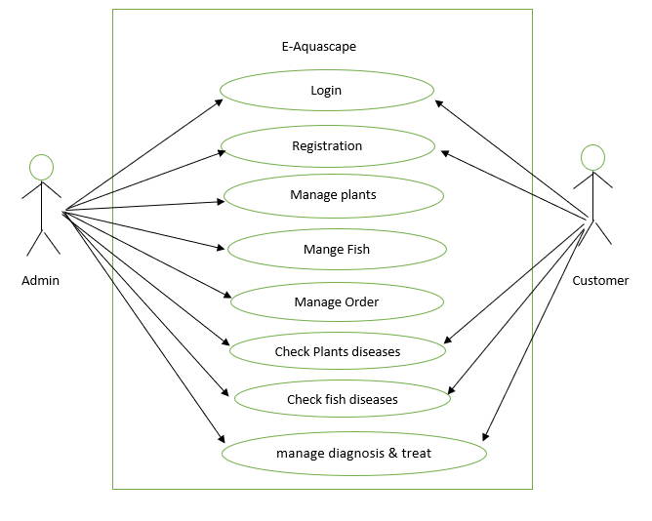

Figure Use Case Diagram

In this "E-Aquascape" application, the customer's most apparent factor. Other actor admin can be controlling all system parts from the backend.

A customer will need to check plants and fish diseases, check diagnosis & treat for the diseases, and similar functions in this system. Admin will need to Manage all plants and fish, manage orders, Manage all customers, View Reports, and similar operations. So, all of these can be considered as use cases.

### **Database Logical Schema**

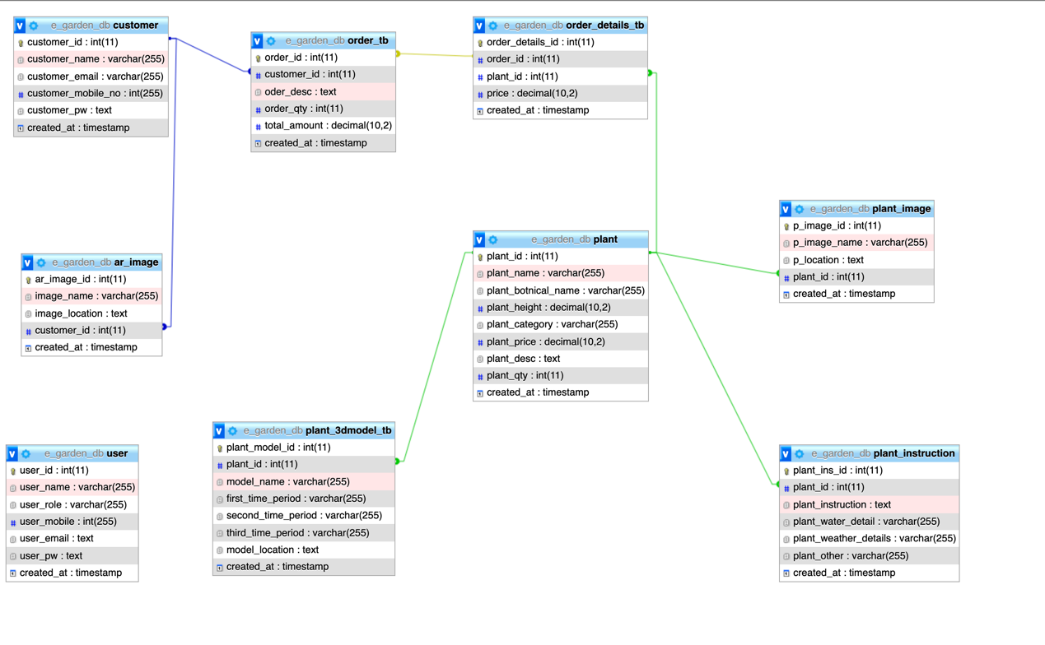

Figure Database Logical Schema

### **System Architecture Diagram**

Below, you can see a system architecture overview of the e-aquascape application. In this diagram, When the user connects with the application, it connects with the server, backend service, and the database I created. After understanding the High-level diagram, I hope to design database architecture based on it and start developing the system.



**WEB Application**

Figure System Architecture Diagram

## **Code samples and 3rd party components**

In this subchapter, the developer will clearly describe important code samples, 3rd party

components, and the usage of mentioned functions. The following description will properly

describe it.

This is the PHP file upload service. This service is used to handle all the file uploading actions.

This service has three main functionalities: upload files, get file upload path and store the file.

When the user requests to upload a file, the requested controller will call this PHP upload file

function in this service. Then inside this function, this service will call the store file function with

two parameters: the uploaded file, a multipart file type, file name, and folder. After the file is

uploaded successfully to the folder, the store file function will return the file upload path, and

then the return path will store in the database.

**File upload path: e-aquascape-admin/uploads/plant**

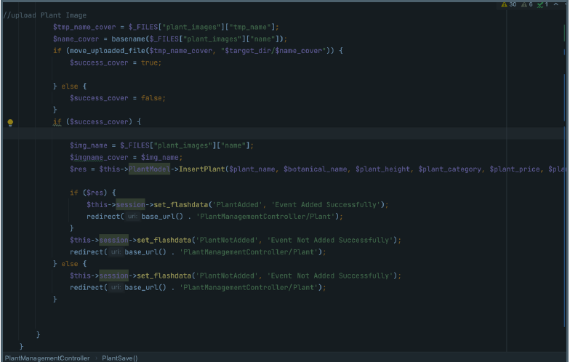

Figure File Upload Backend Service

Database connection and other project configurations such as file uploading multipart

configurations are done in config.php file and database.php file and the following figure shows it

clearly.

# **Chapter 7 testing and verification**

This is the seventh chapter of this project. Some sub-chapters are the test plan of this project

and test cases in this chapter. These two subchapters will show the quality and the performance of

the project. The following subchapters will describe more details about this.

|  |  |  |  |
| --- | --- | --- | --- |
| **Test ID** | **Condition Tested** | **Expected**  **Result** | **Actual Result** |
| 1 | Admin  Login  -  If  Login  Success | Redirect to  the  Dashboard |  |
| 2 | Admin  Login  -  If Email Or  Password  Incorrect | Invalid  Email Or  Password |  |
| 3 | Customer  Login  -  If  Login  Success | Redirect To  The  Customer  Dashboard |  |
| 4 | Customer  Login  -  If Email Or  Password  Incorrect | Invalid  Email Or  Password |  |

|  |  |  |  |
| --- | --- | --- | --- |
| 5 | Customer  Register  -  If Field  Empty | Please Fill  In the All  Fields |  |

|  |  |  |  |
| --- | --- | --- | --- |
| 6 | Customer  Register  -  If Confirm  Password  Does not  Match | Password  Did Not  Match |  |

# Chapter 8 EVALUATION and CONCLUSION

This is the eighth main chapter of this report, and this chapter acts as the report's conclusion. Here

it will summarize the major parts of the project and the relation between the conceptual

frameworks and the research part of this project.

In this report, the developer has presented the documentation on the project on the E-Aquascape

Application. The developer gathered requirements in a proper manner, and the developer created

the task list according to the priority, and then the developer completed the project successfully in

the given timeline.

In the proposed E- Aquascape Application, the developer has implemented some main functionalities admin can manage plants, fish and manage customers. And the Customer can register to the application and manage their own profiles. AI Function will help the Customer to find the diseases to plant trees, users can manage plants health, and users can check plants and fish health using this platform.

# References

* <https://agricultureandfoodsecurity.biomedcentral.com/articles/10.1186/2048-7010-2-8>[Accessed 30 Jan. 2023].
* Home Guides | SF Gate. (2012). *The Advantages of Home Gardens*. [online] Available at: <https://homeguides.sfgate.com/advantages-home-gardens-39103.html> [Accessed 30 Jan. 2023].
* Brainly.ph. (2022). *What is the importance of gardening? please answer in a short but precise sentence thank you.​*. [online] Available at: <https://brainly.ph/question/23996806> [Accessed 30 Jan. 2023].
* Agile Methodology: Definition, Stages, Types, and Benefits. <https://www.atatus.com/glossary/agile-methodology/>
* Azuma, R.T. (1997). A Survey of Augmented Reality. *Presence: Teleoperators and Virtual Environments*, [online] 6(4), pp.355–385. Available at: <https://direct.mit.edu/pvar/article-abstract/6/4/355/18336/A-Survey-of-Augmented-Reality?redirectedFrom=fulltext> [Accessed 15 Jan. 2023].
* Azuma, R., Baillot, Y., Behringer, R., Feiner, S., Julier, S. and MacIntyre, B. (2001). Recent advances in augmented reality. *IEEE Computer Graphics and Applications*, [online] 21(6), pp.34–47. Available at: <https://ieeexplore.ieee.org/abstract/document/963459>[Accessed 15 Jan. 2023].
* Python.org. (2016). *12. Virtual Environments and Packages — Python 3.10.2 documentation*. [online] Available at: <https://docs.python.org/3/tutorial/venv.html>[Accessed 12 Jan. 2023].
* Fukatsu, T. and Nanseki, T. (2009). Monitoring System for Farming Operations with Wearable Devices Utilized Sensor Networks. *Sensors*, [online] 9(8), pp.6171–6184. Available at: <https://www.mdpi.com/1424-8220/9/8/6171>[Accessed 15 Jan. 2023].
* Reinhart, G. and Patron, C. (2003). Integrating Augmented Reality in the Assembly Domain - Fundamentals, Benefits and Applications. *CIRP Annals*, [online] 52(1), pp.5–8. Available at: <https://www.sciencedirect.com/science/article/abs/pii/S0007850607605174>[Accessed 15 Jan. 2023].
* Springer. (2019). *Precision Agriculture*. [online] Available at: [https://www.springer.com/journal/11119 - :~:text='Precision agriculture is a management,, productivity, quality, profitability and](https://www.springer.com/journal/11119#:~:text='Precision%20agriculture%20is%20a%20management,%2C%20productivity%2C%20quality%2C%20profitability%20and)[Accessed 15 Jan. 2023].
* Nih.gov. (2022). *Magnetic Resonance Imaging (MRI)*. [online] Available at: Nih.gov. (2022). Magnetic Resonance Imaging (MRI). [online] Available at: https://www.nibib.nih.gov/science-education/science-topics/magnetic-resonance-imaging-mri [Accessed 12 Jan. 2023]. ‌ [Accessed 15 Jan. 2023].

# Appendices

## **Screenshots in Developed System**

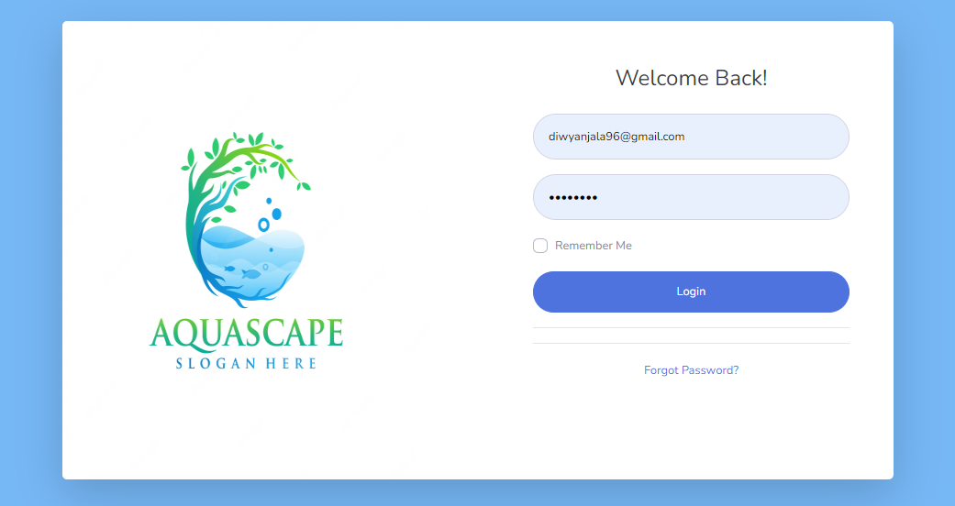

Figure Admin and user Login UI

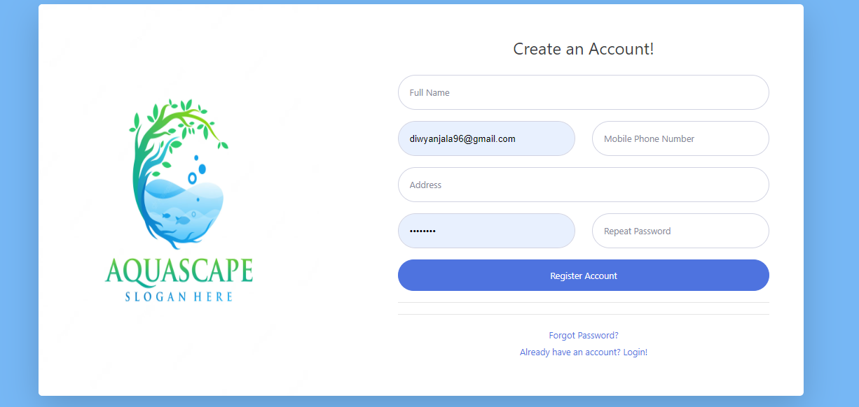

Figure customer register UI

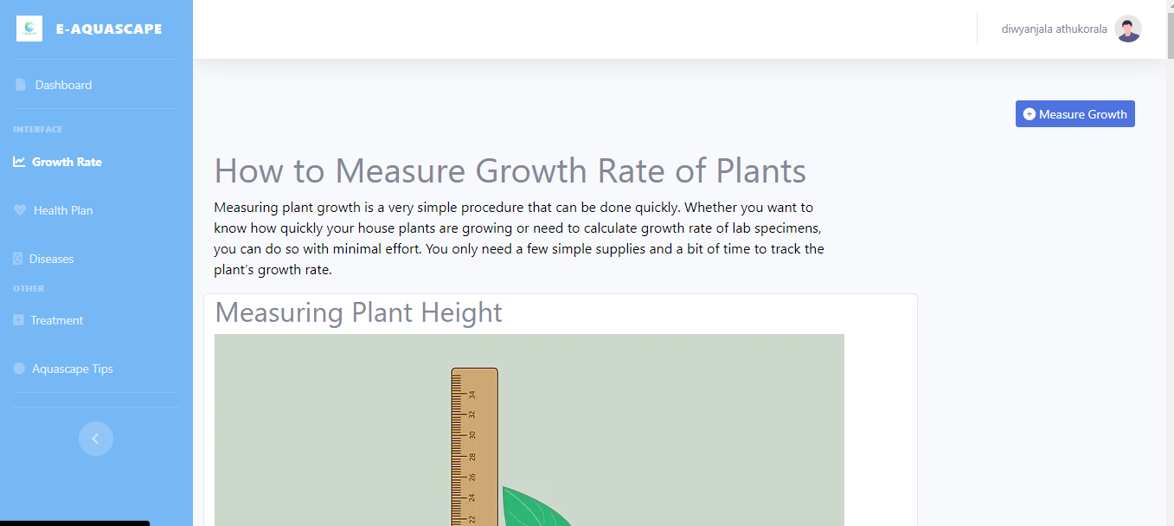

Figure measure plan of growth rate UI

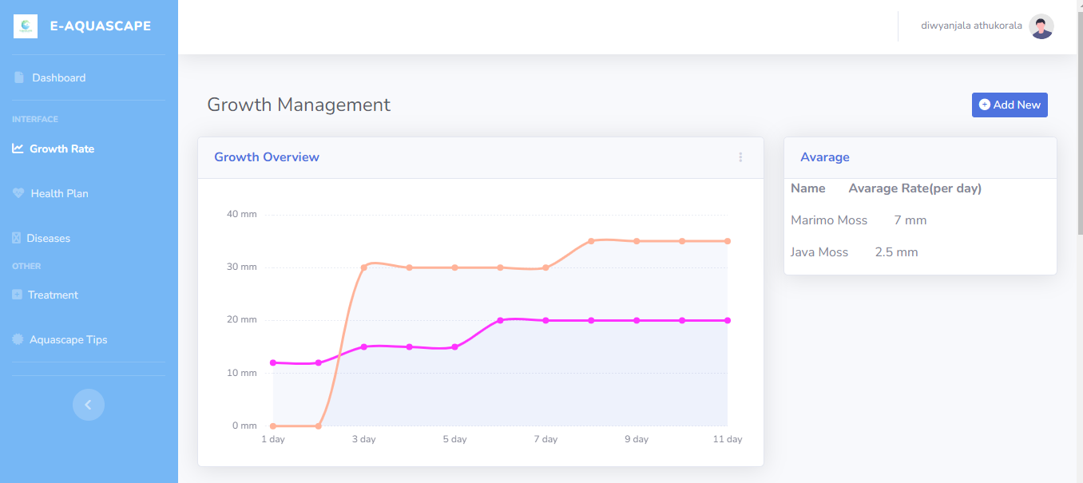

Figure growth chart UI

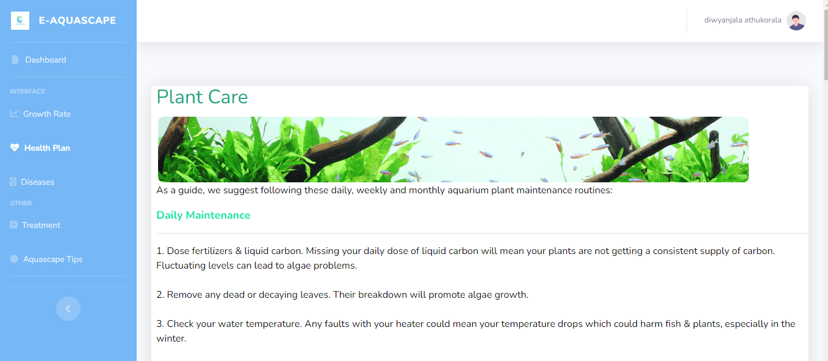

Figure Health plan UI

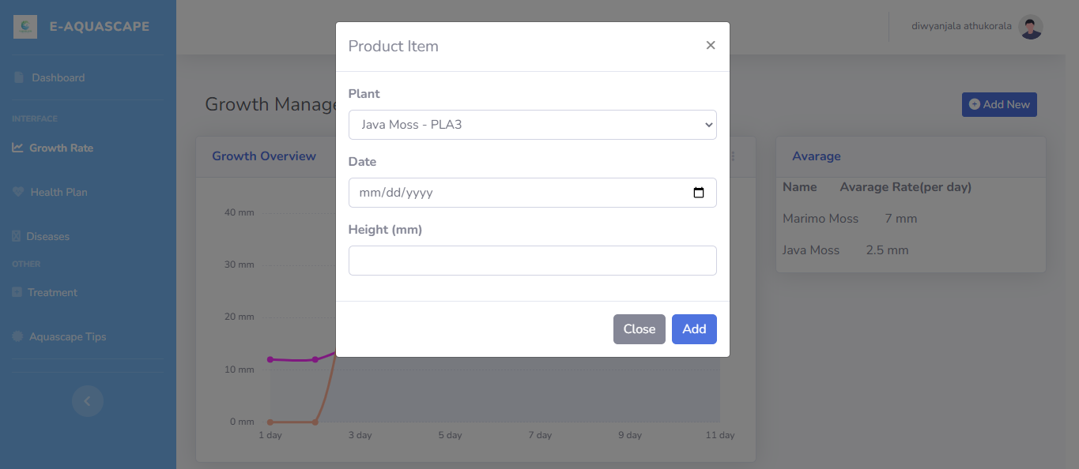

Figure Plant rate insert UI

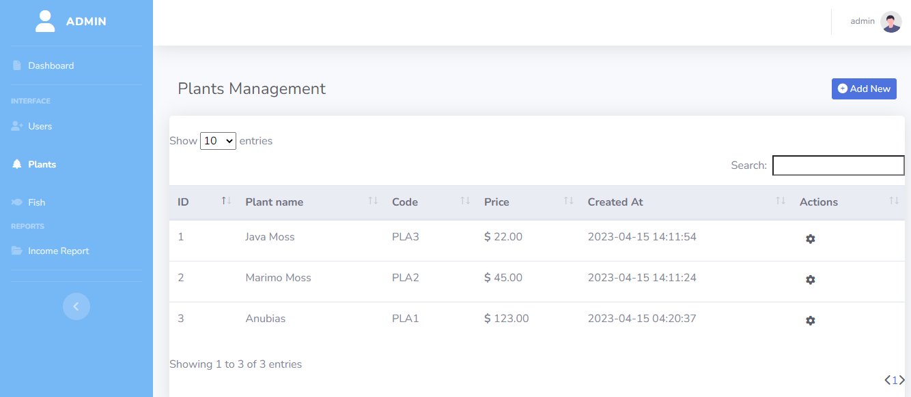

Figure View all plants UI

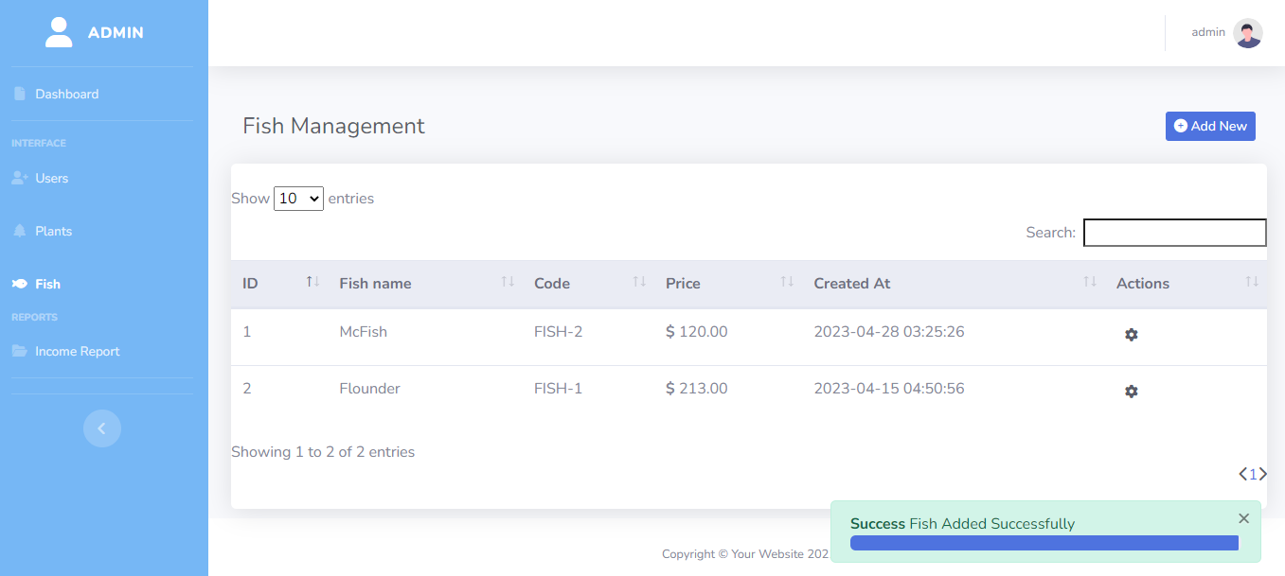

Figure View all fish UI

## **Interim Progress Reports**

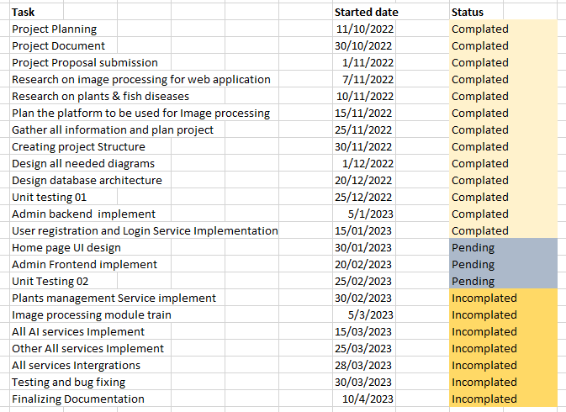

Figure Interim Progress

## **Progress approval form and Project commencement meeting sheet.**

|  |  |  |  |  |  |
| --- | --- | --- | --- | --- | --- |
| **Meeting** | **Criteria** | **Suggestions** | **Actions** | **Date** | **Signature** |
| **Proposal Stage** | | | | | |
| 1 | Project topic  approval | The developer has  suggested many  project ideas at the  beginning and the  supervisor advised  on ways to select a  suitable project  idea | The developer  selected the  project topic of  E-Aquascape Web  Application | 2022/10/11 |  |
| 2 | Project  proposal  approval | The developer  designed the  project proposal.  The supervisor  gives some advices  to create this  document | The developer  designed the  project proposal.  The supervisor  gives some  advices to create  this document | 2022/10/30 |  |

|  |  |  |  |  |  |
| --- | --- | --- | --- | --- | --- |
| **Interim & Final Stage** | | | | | |
| 3 | Literature  review  (Gathered  resource  documents) | Supervisor asked to  add some more  citations in the  literature review |  | 2022/11/10 |  |
| 4 | Literature  review  (Report) | Advice to add  references and  check  the grammar and  usage of language | Completed  successfully, facts  were collected  using reliable  sources. | 2022/10/15 |  |
| 5 | Approach  (Users, Input,  Output,  Technologies  Used | The student has  studied about the  various  technologies  and have come up  with the users and  the main activities | Researched the  topic and went  through several  technologies to be  used with  implementation | 2022/12/01 |  |
| 6 | Project Design | Given suggestions  on  diagrams required  for  the documentation | Add required  diagram as  informed by the  supervisor | 2022/12/05 |  |
| 7 | Implementation  (Algorithms,  Flow charts,  System, etc.) | Advised to  implement all the  functionalities of  the  proposed system | Advised to  implement all the  functionalities of  the  proposed system | 2021/12/10 |  |
| 8 | Evaluation  (Testing  evidence) | Supervisor  suggested to add  more test scenarios | Presented the  completed test  plan  and test cases |  |  |
| 9 | Conclusion  (Result  interpretation,  Achievement  of objectives,  Limitations) &  Further work | Student was  advised  to complete the  report with places  that should be  corrected properly | Final report was  completed and  presented again  after the  corrections | 2023/04/28 |  |
| 10 | Guidance for  the final viva | Guided to focus on  main functionalities  with explanation of  source codes when  demonstrating the  system |  |  |  |